Calculate Your Net Worth - Full Answer
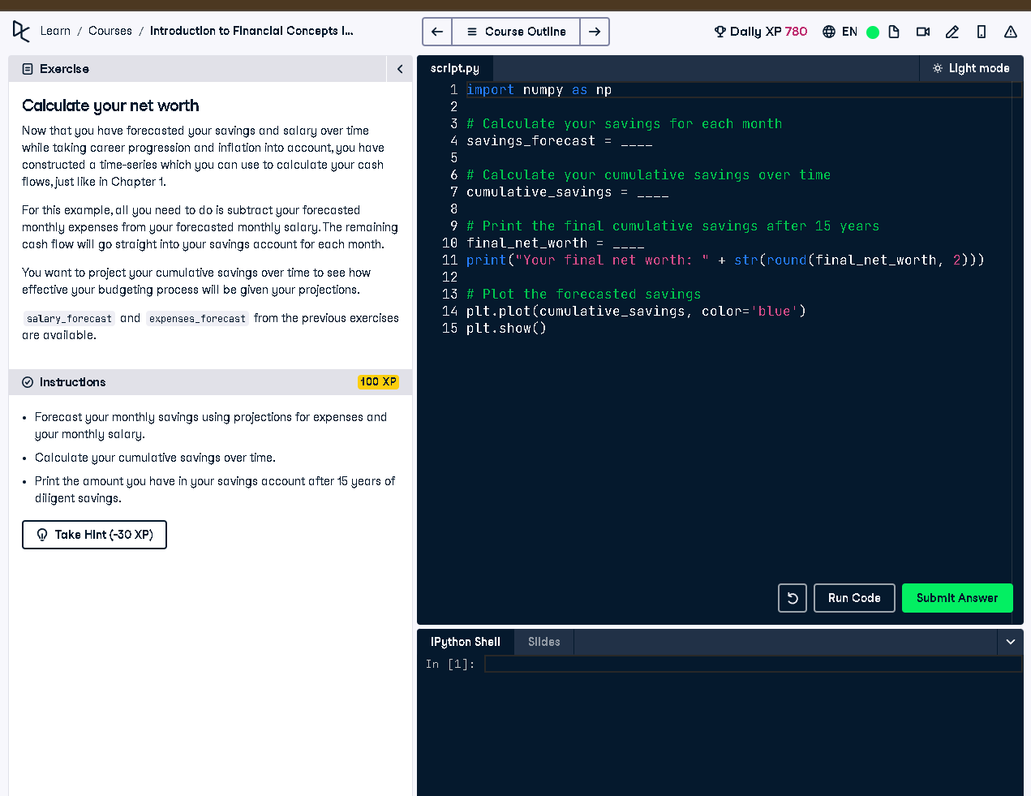

Full Code Answer:
import numpy as np
# Calculate your savings for each month
savings_forecast = salary_forecast - expenses_forecast
# Calculate your cumulative savings over time
cumulative_savings = np.cumsum(savings_forecast)
# Print the final cumulative savings after 15 years
final_net_worth = cumulative_savings[-1]
print("Your final net worth: " + str(round(final_net_worth, 2)))
# Plot the forecasted savings
plt.plot(cumulative_savings, color='blue')
plt.show()

Question:
How can you calculate and project cumulative savings over 15 years using salary and expense forecasts?

20-word Explanation (Question):
Cumulative savings projection helps visualize how income minus expenses accumulates over time, showing long-term financial health trends.

Answer:
Subtract expenses_forecast from salary_forecast monthly, then apply np.cumsum to accumulate savings and determine final net worth.

20-word Explanation (Answer):
By subtracting expenses from salary each month and summing progressively, we estimate net worth growth over a 15-year span.

